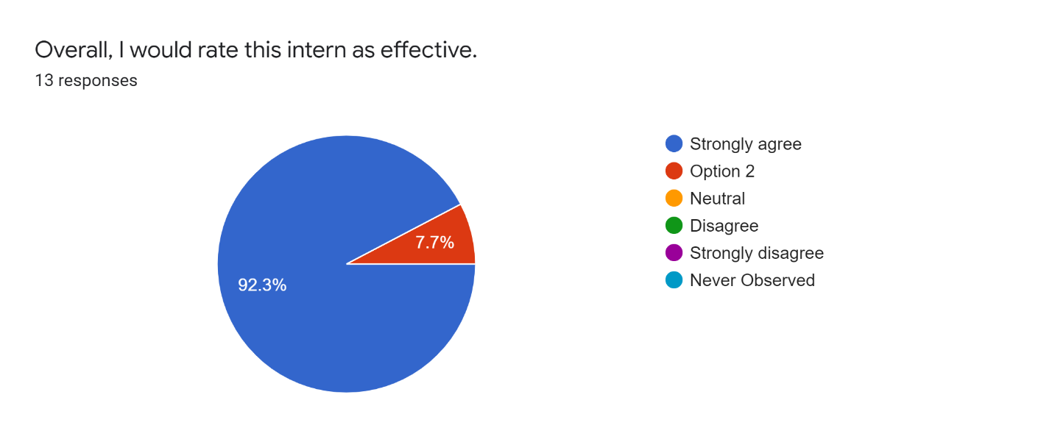
Student Evaluations of Teaching Intern: Erica Rhoads
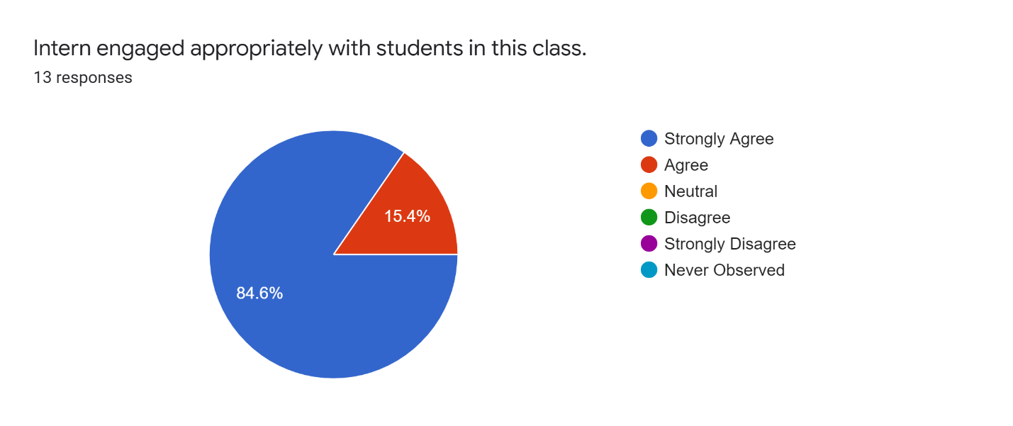
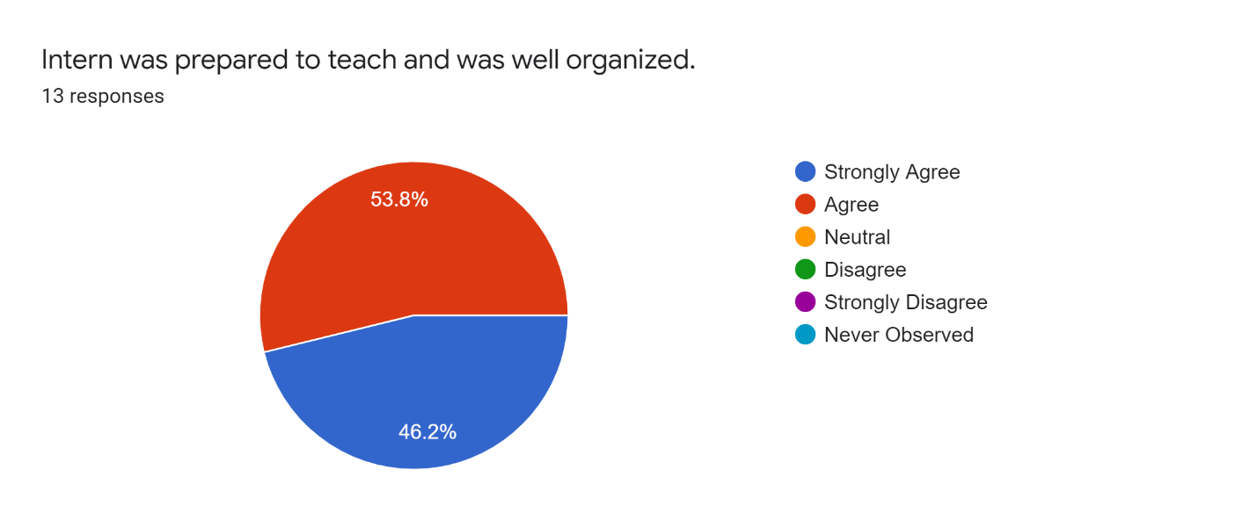
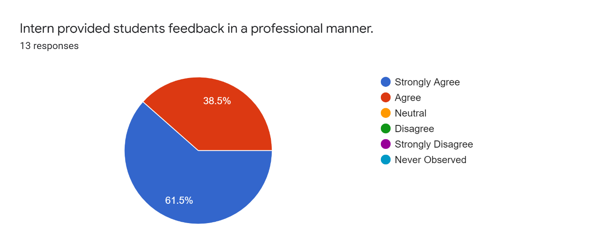
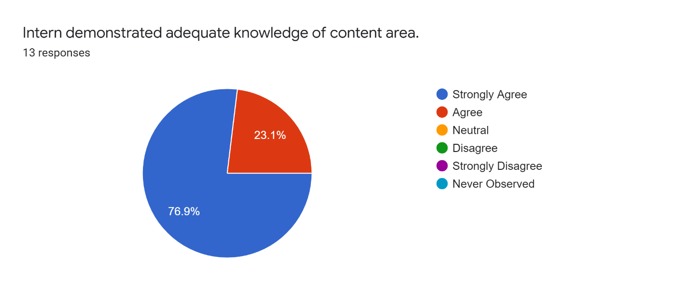
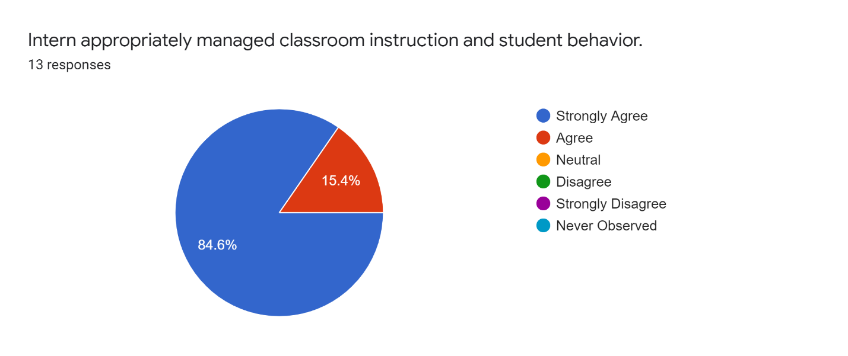
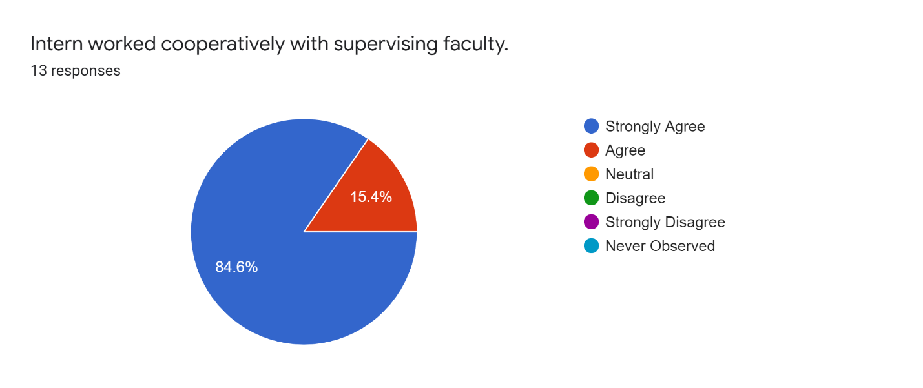
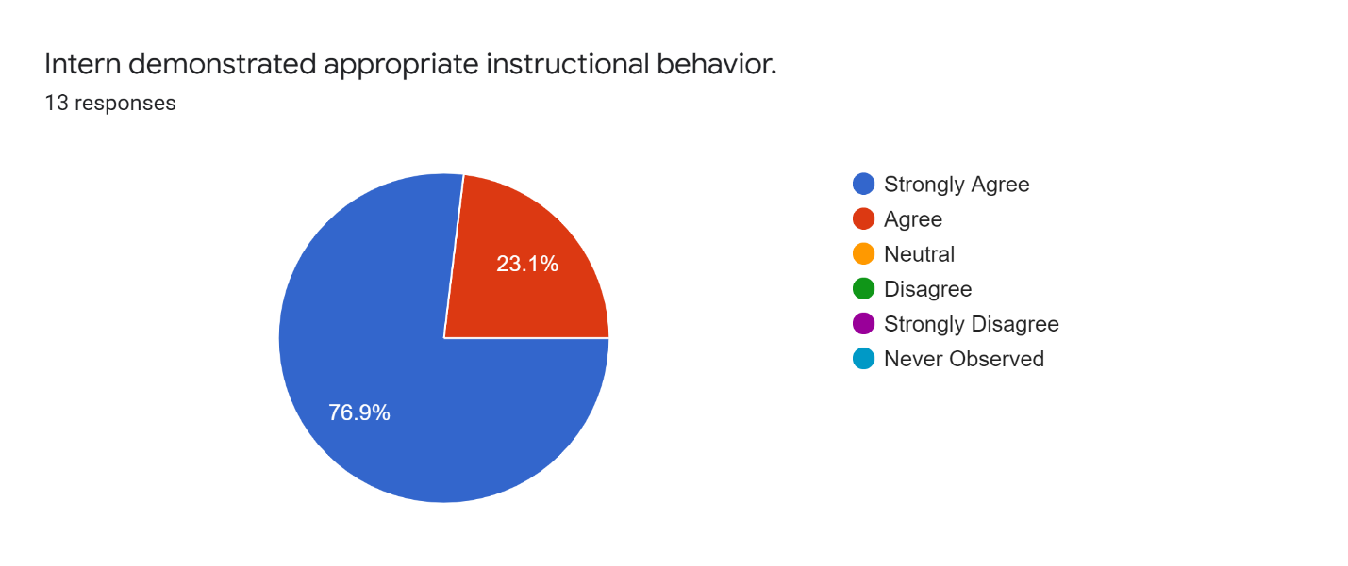
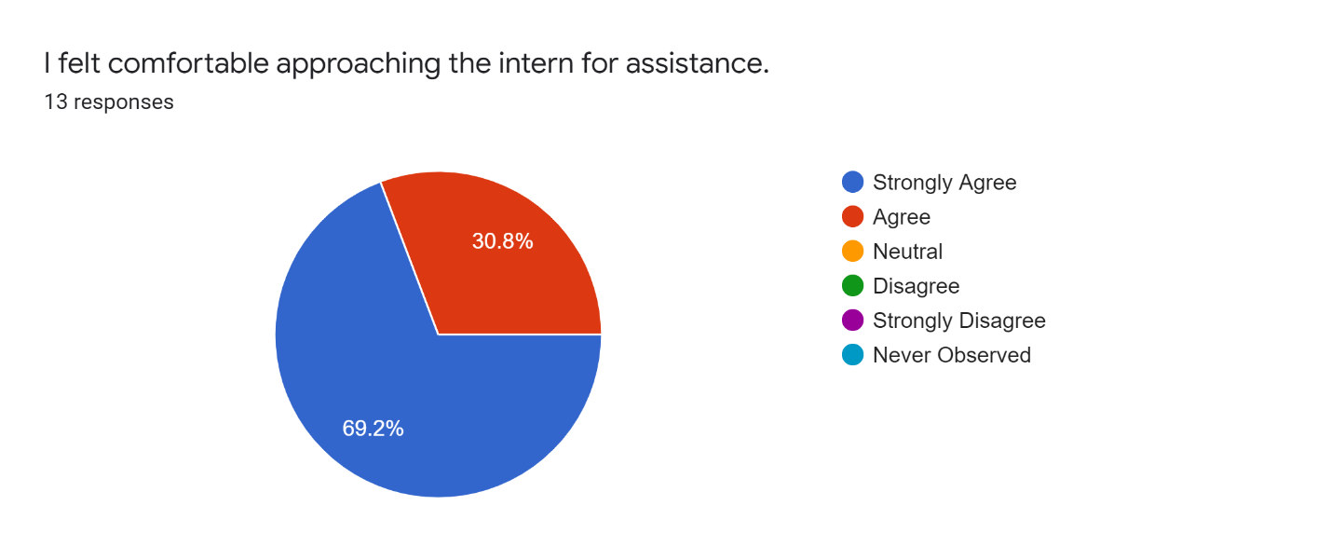
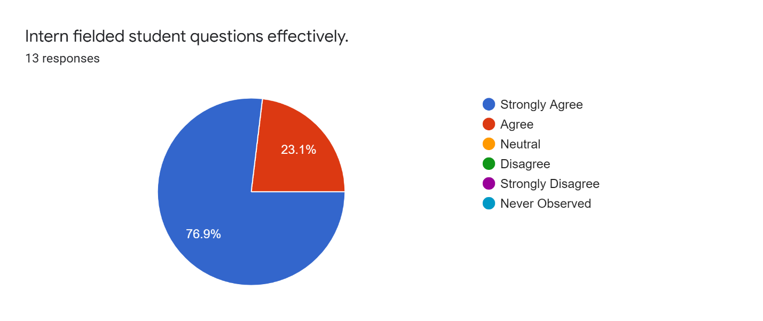
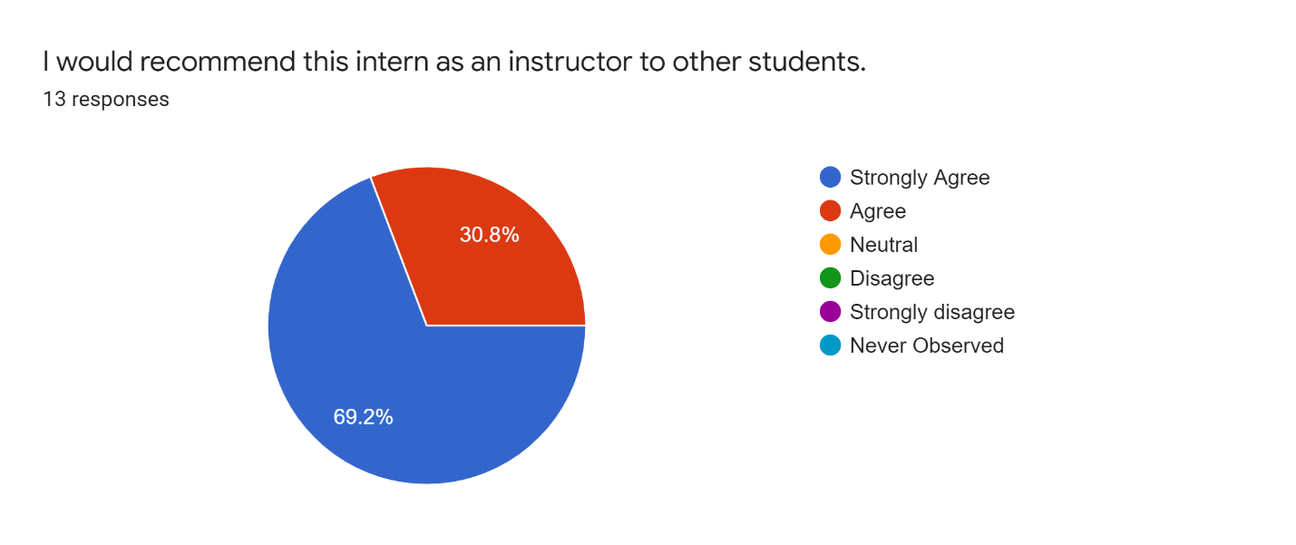
What are the strengths of this intern?
Insightfulness
empathetic knowledgeable
connecting with students
Accessible, approachable, kind, generous, informative, and knowledgable.
Empathetic, Relational, and strongly passionate about caring for others
Very good at facilitating conversations among students.
Professor Rhoads is warm and caring. In all of my interactions with her, I felt of her kindness and compassion. There was an instance where I met with her and Dr. Kirk, and I was feeling very anxious and emotional. Professor Rhoads figuratively took my hand and helped me feel like a was a part of a sisterhood of care and compassion. She strikes an excellent balance between professionalism, and being her warm, genuine, authentic self. There was another instance where she was leading class, and it was a tough day for her. She did an excellent job of being transparent, so the class could adequately support and stand by her. In all that she does, she is respectful to Dr. Kirk. You can tell they have a strong bond. She is compassionate and caring of the students. She is professional, and smart, while also appearing as a real authentic human. She puts you at ease, she utilizes appropriate self-disclosure, and again, she is both personable and professional. You couldn't gain a between teacher than Professor Rhoads. She is a diamond in this very rough world. I would strongly recommend her to any classmate, or university.
Empathy, understanding, mindful, supportive
She was kind, patient, and understanding when working with our class
That she was understanding and had empathy.
encouraging, friendly, vulnerable, supportive.
I found that Dr. Roads was not only helpful but also super comfortable when I had questions. I never felt that my questions were not answered. She engaged with us frequently and worked alongside Dr. Kirk.
What are the areas of improvement for this intern?
Shorten the lessons to make them more engaging and less scripted
N/A
tech
I have none
had trouble with computer software at times but who doesn't
There is nothing coming to mind. I think she is exactly where she needs to be in her developing journey.
Professor Rhoads went above and beyond helping us grow within the 505 course.
Confidence- she has great things to say, I feel sometimes she does not 100% believe in herself
When teaching the lessons having more visual aids like videos and pictures about the subject.
n/a
become more user-friendly with technology and more relaxed.
I don't have an area of improvement only because when I did my triad weekly groups, I worked with the other professor more. So, it is hard to give feedback on improvement when I didn't get to know her better. But from what I have seen she is very well-rounded and knows the material very well.

Do you feel that this intern helped you to develop as a counselor? If so, how? If not, how could they have contributed more to your development as a counselor?
Yes
Yes, she provided feedback that taught me my strengths and weaknesses in counseling.
Yes, because it showed me what I need to do when I go for my internship.
YES!
I believe they encouraged me to be the best version of myself, so that I can be the best counselor in the future. Her relational character really helped to build an understanding of what genuine connection and trust looked like.
Yes, I feel Prof. Rhodes brought a level of realness to the class with expressed empathy and compassion for us as students since she is also still a student. This helped by providing me with a sense of patience and understanding with myself as she often eased expectations and pressures of being a student and real life.
She taught me that 1) It's okay if friends get put on hold during school 2) not all areas of life have to be equally balanced all the time 3) the importance of self-monitoring and regulation 4) that it's okay to be human 5) that it's okay to make mistakes 6) it's okay to be transparent 7) we can be both professional and authentic ... and so many other things I've learned much from the kind and nurturing spirit of Professor Rhoads.
Yes, she showed us immediacy and the tools we needed to be successful within the course and outside of the course.
Yes, she gave me great feedback and I felt was able to highlight my strengths and weaknesses in a way that encouraged me
I believe she has shown me that counselors still are people that have feelings.
yes, helped me understand that we are all learning and to be kind to ourselves.
Yes, she was vulnerable, supportive, and gave good advice.
Yes, I learned a lot in class when she was the one presenting.

